Software Design Specification

<Face Analyzer>

Internal Advisor:
Prof.Muhammad Fahad

Project Manager:
Prof.Dr.Muhammad Ilyas

Project Team:
Amna Aslam (BSCS51F22S038)
Bushra Bilqees (BSCS51F22S041)

Submission Date:

16-12-2025

_____________________
Project Manager’s Signature

Document Information

Category | Information
Customer | UOS – Department of Computer Science
Project | <Face Analyzer>
Document | Software Design Specification
Document Version | 1.0
Identifier | BSCS-51-F-22-S
Status | Draft
Author(s) | Amna Aslam (BSCS51F22S038)  Bushra Bilqees (BSCS51F22S041)
Approver(s) | PM
Issue Date | Dec. 16, 2025
Document Location
Distribution | - Advisor  - PM  - Project Office

Definition of Terms, Acronyms and Abbreviations

Term | Description
RS | Requirements Specifications - outlining the functional and non-functional needs of the website.
HTML | Hyper Text Markup Language - the standard language for building web pages.
CSS | Cascading Style Sheets - used for styling the website.
JS | JavaScript, scripting language to make the website interactive.
HTTPS | Hyper Text Transfer Protocol Secure - ensures secure data communication over the internet using encryption.
GDPR | General Data Protection Regulation - a data privacy regulation ensuring user consent and secure handling of personal data.
SSL | Secure Sockets Layer.
TSL | Transport Layer Security.
CNN | Convolutional Neural Network - a type of deep learning model used for image recognition and analysis, especially in skin feature detection.
UI | User Interface - the visual elements through which users interact with the website.
UX | User Experience - the overall experience and satisfaction a user has when interacting with the website.

Table of Contents

1. Introduction 4
1.1 Purpose of Document 4
1.2 Project Overview 4
1.3 Scope 4
2. Design Considerations 5
2.1 Assumptions and Dependencies 5
2.2 Risks and Volatile Areas 6
3. System Architecture 6
3.1 System Level Architecture 6
3.2 Sub-System / Component / Module Level Architecture 7
3.3 Sub-Component / Sub-Module Level Architecture (1…n) 8
4. Design Strategies 9
4.1 Strategy 1…n 9
5. Detailed System Design 10
6.References……………………………………………………………………………………..13

Introduction

  - Purpose of Document
This Software Design Specification (SDS) document defines the detailed design of the AI Face Analyzer, a web-based system that analyzes facial images to detect skin issues using AI and image processing. The purpose of this document is to describe the system structure, architecture, components, design strategies, and internal interactions that guide developers, designers, and stakeholders during implementation. The intended audience includes the project manager, internal advisor, development team, database engineers, UI/UX designers, testers and any technical personnel involved in building or maintaining the system.
The project will utilize an Object-Oriented Design (OOD) methodology supported by UML diagrams such as class diagrams, sequence diagrams, state diagrams, and component diagrams.

  - Project Overview
The AI Face Analyzer is a responsive web application that allows users to upload facial images and receive detailed skin issue analysis. Using advanced Artificial Intelligence models (CNN-based image processing), the system identifies conditions such as acne, pigmentation, wrinkles, dark spots, fine lines, and uneven skin tone. Results are presented as percentage-based values, enabling users to understand skin condition severity.
The system architecture is based on a three-tier design:
- Frontend: Responsive UI for image upload, report viewing, and dashboard access.
- Backend: Handles authentication, image processing requests, and communication between modules.
- AI Processing Layer: Performs facial detection, feature extraction, and skin analysis using trained machine learning models.
The design prioritizes accuracy, speed, scalability, security, and user data privacy.

  - Scope

In-Scope
- User registration, login, and session management.
- Uploading high-quality facial images.
- AI-based analysis for acne, pigmentation, wrinkles, dark spots, and uneven tone.
- Percentage-based report generation.
- User dashboard with history tracking and comparison.
- Secure image handling and GDPR-compliant privacy measures.
- Responsive frontend for desktop and mobile.
- Admin features such as dataset management and AI model updates.

Out-of-Scope
- Real-time video-based skin analysis.
- Medical diagnosis, treatment advice, or professional recommendations.
- Integration with clinics, dermatologists, or health systems.
- Highly advanced or rare skin condition detection (e.g., cancer).
- Native mobile apps (Android/iOS).
- Offline usage or multi-face analysis in group photos.

Design Considerations
This section describes many of the issues which need to be addressed or resolved before attempting to devise a complete design solution. In other words, this section is used to formally set the groundwork for the system design.

  - Assumptions and Dependencies

Assumptions
- Users will upload clear and well-lit facial images to ensure accurate AI processing.
- The AI model has been pretrained on dermatologically verified datasets, enabling reliable classification.
- The system will run on a cloud-supported backend capable of handling GPU-based AI computations.
- Users will operate on modern browsers supporting HTML5, CSS3, and JavaScript.
- Stable internet connectivity is available for image upload and receiving real-time analysis.

Dependencies
- AI model accuracy depends upon:
  - CNN architectures (e.g., TensorFlow or PyTorch models).
  - Dataset diversity, quality and size.
- Backend depends on:
  - Secure server environment.
  - Database (MySQL, MongoDB or Firebase).
  - Cloud storage for temporarily handling images.
  - Encryption libraries for GDPR compliance.
- Web interface depends on:
  - Responsive design framework (HTML/CSS/JS).
  - API availability for sending image data to the backend.
- System relies on:
  - Scalability support for handling multiple concurrent users.

  - Risks and Volatile Areas

Technical Risks
- AI Model Accuracy Risk: Misclassification due to poor image quality or limited training data.
- Scalability Risk: High number of concurrent users may affect performance.
- Security Risk: Sensitive images require strong protection; any breach can harm user trust.

Volatile Areas
- AI model updates may require structural changes.
- Skin issue categories may expand with future features.
- New privacy regulations may require updates in data storage.

Mitigation Strategies
- Build retraining support for datasets.
- Use GPU-enabled servers to enhance processing speed.
- Implement strong encryption and access control.
- Maintain modular architecture for easy modifications.

System Architecture
This section should provide a high-level overview of how the functionality and responsibilities of the system are partitioned and then assigned to subsystems or components. The main purpose is to gain a general understanding of how the system is decomposed, and how the individual parts work together to provide the desired functionality.

  - System Level Architecture
At the system level, the AI Face Analyzer is organized into three major layers that work together to process user requests and generate skin analysis results.
Frontend Layer
The frontend layer provides a responsive web interface where users can register, log in, upload facial images, and view analysis reports. It is developed using HTML, CSS, and JavaScript to ensure compatibility across modern browsers and devices. This layer handles user interaction and communicates with the backend through secure APIs.

Backend Layer
The backend layer acts as the central control unit of the system. It manages user authentication, request validation, session handling, and communication between the frontend and AI processing layer. It also controls secure image transfer, temporary storage, and report generation.

AI Processing Layer
This layer is responsible for image analysis and skin condition detection. It uses CNN-based machine learning models to extract facial features and identify skin issues such as acne, pigmentation, wrinkles, and uneven tone. GPU-enabled servers are used to improve processing speed and accuracy.
All communication between layers is protected using HTTPS with SSL/TLS encryption, ensuring data privacy and security.

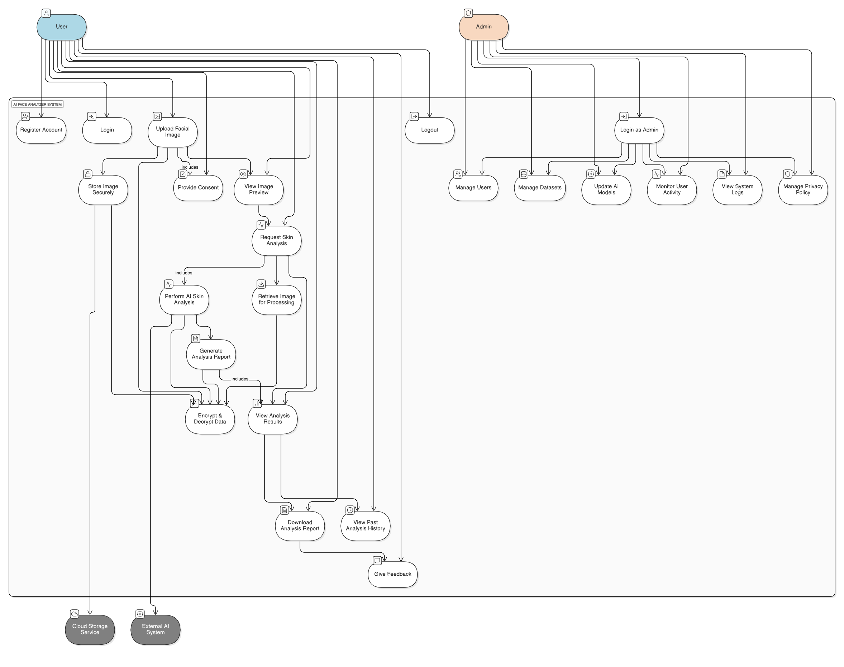

  - Sub-System / Component / Module Level Architecture
The system is further divided into multiple subsystems and modules, each responsible for specific functionalities:

User Management Module
Handles user registration, login, authentication, session management, and access control.
Image Upload & Preprocessing Module
Validates uploaded images, checks quality, resizes images, and prepares them for AI analysis.
AI Analysis Module
Processes facial images using CNN models to detect skin conditions and calculate severity percentages.
Report Generation Module
Converts AI results into user-friendly reports and graphical representations.
Database & Storage Module
Stores user profiles, analysis history, and metadata securely. Images are stored temporarily unless user consent is given.
Admin Module
Allows administrators to manage datasets, update AI models, and monitor system performance.
These modules interact through well-defined APIs, ensuring loose coupling and easier maintenance.

  - Sub-Component / Sub-Module Level Architecture (1…n)
Each major module is further decomposed into sub-components to support detailed functionality:

AI Analysis Sub-Components
- Face Detection
- Feature Extraction
- Skin Condition Classification
- Confidence & Percentage Calculation

User Management Sub-Components
- Authentication Handler
- Session Token Generator
- Access Control Validator

Report Module Sub-Components
- Data Formatter
- Visualization Generator
- History Comparison Engine

Security Sub-Components
- Encryption Manager
- Secure API Gateway
- GDPR Compliance Handler
This layered decomposition ensures high cohesion within modules and low coupling between modules, enabling future scalability and feature expansion without major architectural changes.

Design Strategies

4.1 Strategy 1…n

Strategy 1: Modularity & Reusability
- Each module designed independently to allow easy updates.
- AI model isolated to enable future upgrades without affecting frontend.

Strategy 2: Scalability
- Use microservice-friendly architecture.
- AI processing offloaded to separate inference service.

Strategy 3: Data Security
- HTTPS encryption.
- Secure session tokens.
- GDPR-compliant storage.
- Images not stored permanently unless user consents.

Strategy 4: Performance Optimization
- GPU-enabled inference.
- Caching frequently accessed data.
- Asynchronous image processing.

Strategy 5: Responsive UI/UX
- Mobile-first design.
- Clear visual representation of results.
- User-friendly dashboard.

Detailed System Design

Class Diagram

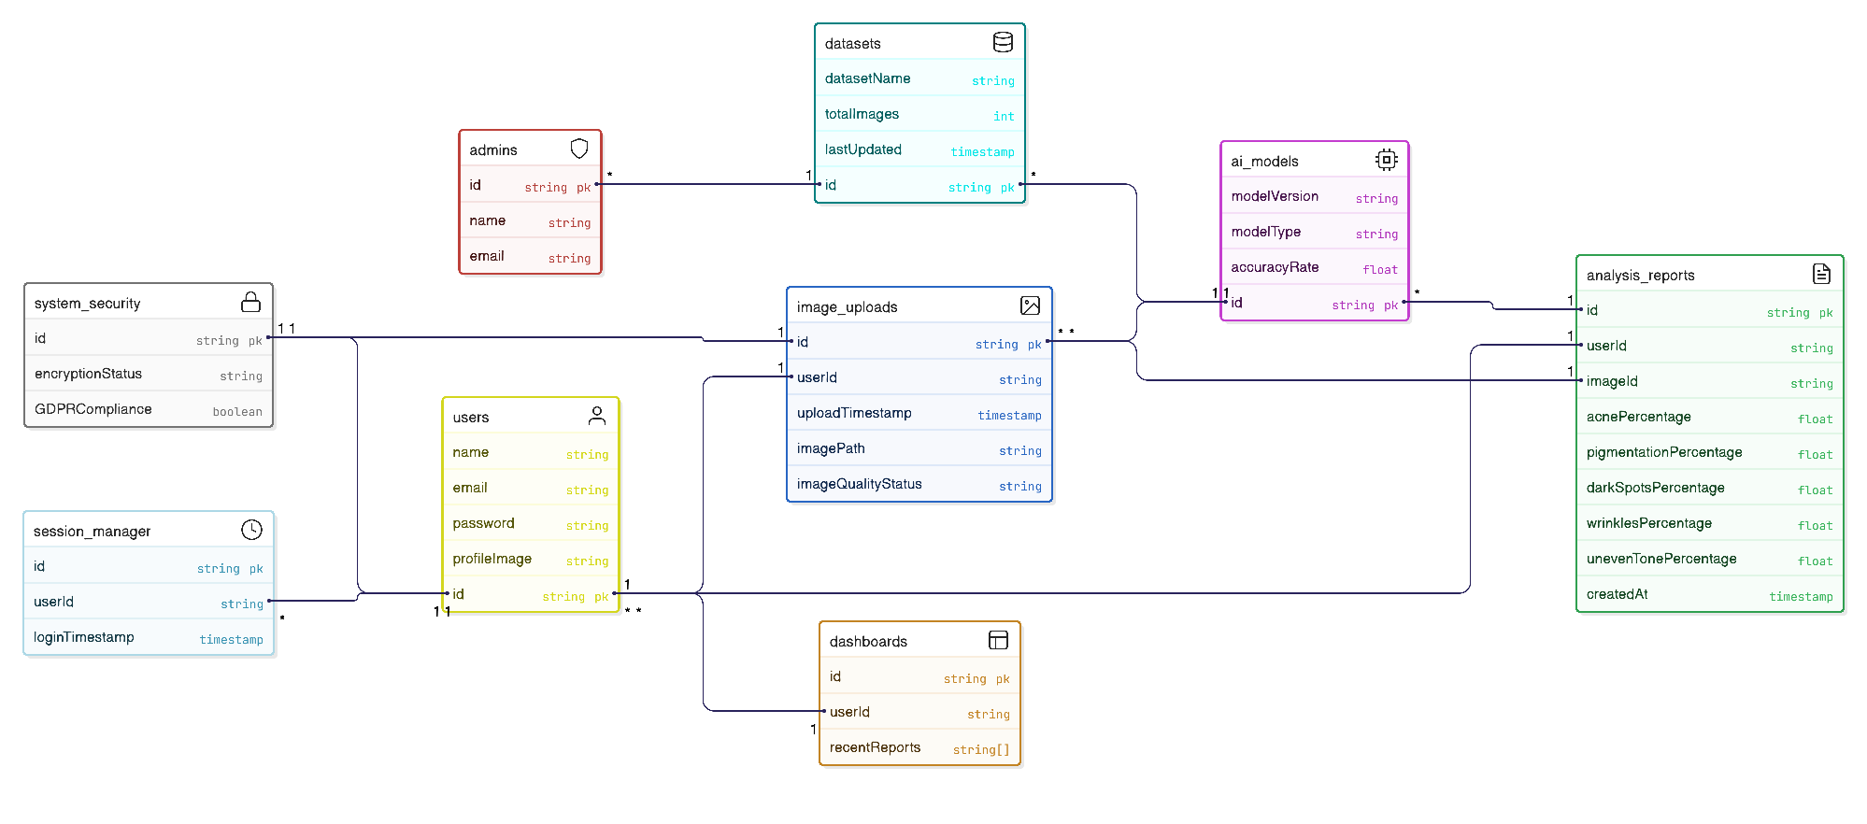

Sequence Diagram
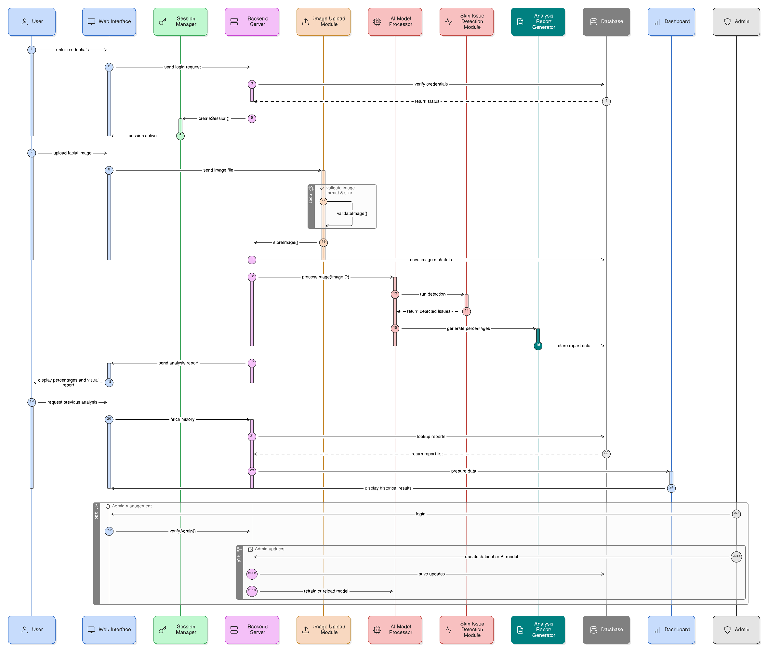
State Transition Diagram

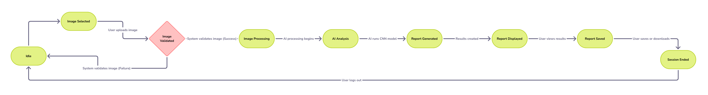

ER Model

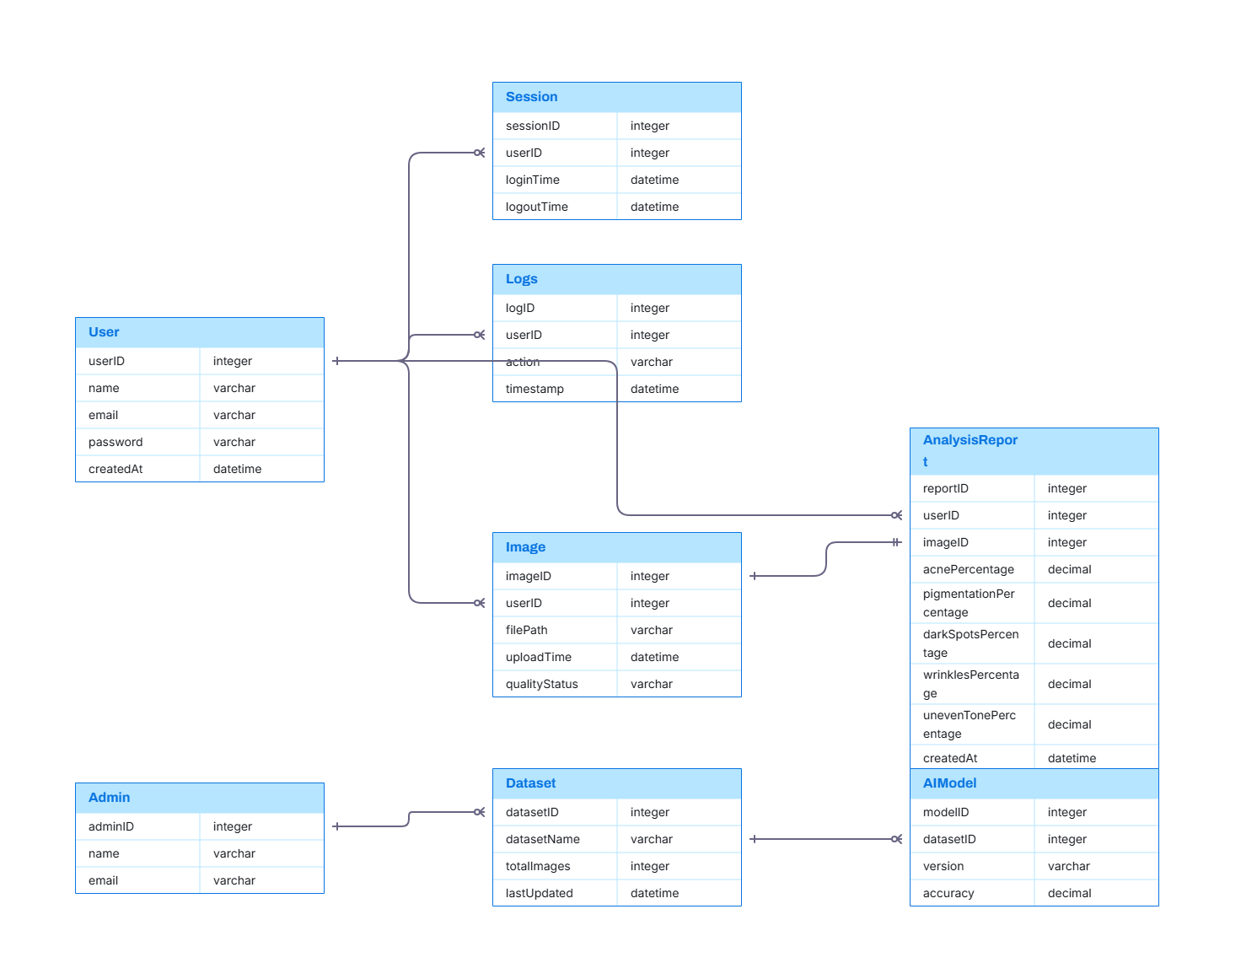

6.References
This section should provide a complete list of all documents referenced at specific point in time. Each document should be identified by title, report number (if applicable), date, and publishing organization. Specify the sources from which the references can be obtained (This section is like the bibliography in a published book).

Ref. No. | Document Title | Date of Release/ Publication | Document Source
PGBH01-2025-Proposal | Project Proposal | Oct 6, 2025 | https://github.com/BushraBilqees/Project/blob/main/final%20year%20project%20proposal.doc
PGBH01-2025-FS | Functional Specification | Oct 20, 2025 | https://github.com/BushraBilqees/Project/blob/main/SRS%20signed%20by%20Supervisor.pdf

